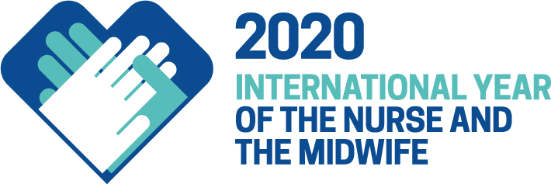

Dear

The World Health Assembly has declared that 2020 will be the International Year of the Nurse and the Midwife. We ask you to join us in celebrating nurses and midwives and their work throughout 2020.

Nursing Now is an international campaign which aims to improve health globally by raising the status and profile of nursing. Throughout 2020 we want to recognize the critical contribution both nursing and midwifery makes to global health, and to highlight the urgent need to invest in them. You can find out more about the campaign at www.nursingnow.org
The world’s 22 million nurses and 2 million midwives make up half of the global health workforce – providing vital health care everywhere. They have been doing this for generations and in 2020 we mark the bicentenary of the birth of the founder of modern nursing, Florence Nightingale.

The achievement of universal health coverage requires political will and domestic resource mobilisation. It’s time for governments to increase their allocation to health budgets and invest in their nursing and midwifery workforce, and also ensure that all nurses and midwives can practice to the top of their licence and stay in the workforce because they feel valued and rewarded.

ADD DETAILS ABOUT YOUR PLANNED ACTIVITIES AND INVITE TO PARTNER WITH YOU
We look forward to hearing from you on your planned activities for the year. You can share them with at (ADD EMAIL) or via the Nursing Now timeline.

On behalf of nurses and midwives everywhere thank you for your support.

