THE NURSING NOW CAMPAIGN PROGRESS IN RWANDA
- Introduction
The Nursing Now Rwanda team is composed by multidisciplinary stake holders which are the Ministry of Health, Ministry of Labour and Public servant, Rwanda Nurses and Midwives Union, National Council of Nurses and Midwives, One Family Health, University of Rwanda School of Nursing and Midwifery, Nurses Students Association, Mount Kenya University Rwanda, Rwanda Association of Midwives, Mental Health Nurses ‘Association, Rwanda Military Hospital, WHO, UNFPA, JPHIEGO, Norwegian Nurses Organization. We are expecting many more organizations to join the campaign.
After being contacted by Global NN Campaign, Rwanda Nurses and Midwives Union (RNMU) has taken initiative to engage stakeholders in the campaign. We met with One Health Family which was also contacted on other side and had together 2 meetings at RNMU head office. We decided to include other organizations. RNMU invited the above mentioned organizations and discussed together the following points:
- Including more stakeholders
- Drafting concept paper for the launch
- Funding opportunity for the launch
- Date and place of launching the campaign in Rwanda
- Other activities that may be carried out during the launch
- NN 3 Years program in Rwanda
RNMU and One Family Health have also sent 4 representatives to attend regional launch in Uganda
- NN Rwanda Stakeholders
We have identified about 30 governmental and civil society organizations that should be invited to join the campaign. It is important to mention that we have about 20 organizations that have participated in NN coordination meetings and accepted to join the campaign. NN team is committed to continue to mobilize other stakeholders to join the campaign. The team has nominated the president of Rwanda Nurses and Midwives Union Mr Andre Gitembagara to Chair the NN Campaign in Rwanda as Acting Chairperson of the Campaign. Good news is that during the launch the Minister of Health has committed to chair the NN team in Rwanda.
- Activity Time frame for the launch
Activity | Period
Meeting of Stake holders | 9th/02/2018
Writing the draft proposal | 12th-15th/02/2018
Update meeting | 16th/02/2018
Contacting stake holders (physical meeting of the key people and sharing concept | 19th/02 to 5th/03/2018
Stake holders meeting | 11th/03/2018
Update Meeting (coordination team) and sending the proposal for request of funding for NN launch | 11th/05/2108
Skype call with the global and regional partners | 25th/05/2018
Update Meeting (coordination team) | 25th/05/2018
Follow up on sponsors, inviting participants/sponsors/media /guest of honor and call for campaign on ground level (coordination team) | 28th/05/2018-11th/06/2018
Stake holders meeting | 15th/06/2018
Preparation of tools by the coordination team | 4th/06 to 15th /06/2018
Update meeting by the coordination team | 22nd/06/2018
IND Celebration and NNC launch | 29th/06/2018

- Concept paper
Rwanda Nurses and Midwives (RNMU) has been tasked to draft the concept paper for the launch to be shared with other stakeholders. The concept has been drafted and shared including budget, invitation letters and the agenda of the launch.
The objectives of the launch were:
- To officially make the NN Campaign known to the Nurses/Midwives and the population at large.
- To share the Global objectives of the NNC with all stakeholders.
- To Encourage and educate the next generation of nursing and midwifery leaders
- Make nursing and midwifery attractive as a profession, one that involves real change-making and policy influence.
- To advocate for home quality and quantity nursing and midwifery education.
- To recognize the experience and education of the nurses and midwives and their contribution to the National health coverage.
- To advocate for nurses and midwives’ working conditions challenges including the number of working hours per week; safe and healthy environment; upgrading level of education for some nurses
- To promote culture of research and clinical evidence based within nursing/midwifery community
- To provide our experience in resolving community issues such as FP, ANC, Nutrition, Skilled birth attendance, Maternal and Child Health among others

- Funding opportunity for the launch
We have shared the concept paper including budget and letters requesting NN organizations members to support the launch but no one has been able to respond positively. Rwanda Nurses and Midwives Union (RNMU) has been able alone to provide fund for NN Campaign launching event combined with celebration of the International Nurses Day on 29th June 2018. The NN launching event budget cost was 15,000,000 FRW (USD14, 500) and was funded by Rwanda Nurses and Midwives Union. During the Launch, RNMU has also provided Community Based Health Insurance to 1,000 poor people in Rulindo district to support access to health care for poor population.

- Date and place of launch
The NN Campaign was launched during the celebration of the International Nurses Day on 29th June 2018 by the Minister of Health and the President of Rwanda Nurses and Midwives Union in Rulindo District located at 30 minutes driving away from Kigali Town. The event has mobilized more than 1,000 nurses, midwives and students and more than 800 local population and community health workers.
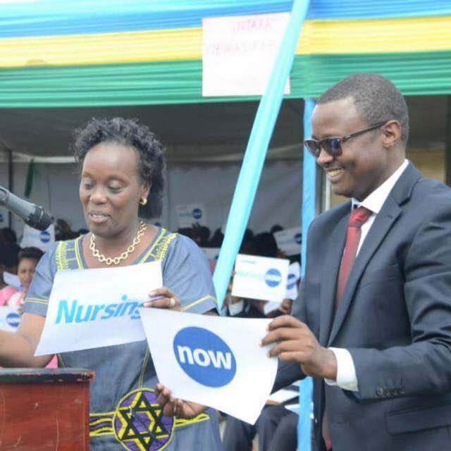
The Hon. Minister of health holds Nursing flyer and the RNMU President holds a Now flyer to declare the campaign launch
- Activities during the launch
- Display (Exhibition) of nurses work
During the launch, nurses and stakeholders organized stands to display their work. Among exhibitors were:
- Nurses from Rulindo district (the host district of the event), displayed their nursing work to improve health population including Family Planning innovations to increase adherence, Antenatal care, Post-natal care, children nutrition, ….
- Nurses’ students showed how they learn good nursing procedures to serve community, together with their teachers, their displayed published and non-published papers that are helping to improve clinical work.
- National Council of Nurses and Midwives displayed their work including the scope of practice, the code of conduct, the nurses and midwives new uniform and attires, etc.
- The Rwanda Nurses and Midwives Union has also displayed its work on nursing capacity building, mentorship activities, research, socio-economic activities to improve nurses/midwives socio economic development and advocacy on labour issues.
- Other partners including One Family Health have also presented their work

- Nursing week.
Nurses in Rulindo district have carried out promotion and preventive activities in the community. Funded by RNMU, nurses in Rulindo district installed 3 outreach sites and mobilized 30 nurses and midwives on the ground to conduct community health activities from 29th June to 5th July, including:
- Reproductive health education
- Family Planning education and provide FP onsite services
- Nutrition education
They are also screening BMI, diabetes and HIV and can transfer to the nearest health facility the screened positive participants.
The same activities were carried out by nurses’ students from University of Rwanda in Rwamagana district from 25th -28th June and got provincial and RNMU financial support.

- NN 3 Years program in Rwanda
Nursing Now Rwanda under Nursing Now Africa will seek to support the aims of the global campaign program on Leadership and Development, advocating, demonstrating, educating and motivating on the impact that developing strong, politically astute nurse leadership will have on being a key driver for successful policy outcomes in Africa achieving universal health coverage. Thus, to reach the above target, NN Rwanda is developing a project proposal that aims following results:
- To have nurses/midwives in leadership positions in health system and other decision making structures
- To have education profile of nurses/midwives improved
- Improved nursing and midwifery research that provides evidence based practice
- The role of nurses and midwives well known in the community as a professional that has impact on socio-economic development of the population and the country
- Increased nurses/midwives activities in the community by organized outreach to provide health services to the population
- Demonstrate the role of nurses and midwives to improve the population’s health
- Nurses and midwives organizations are strong enough to represent the interest of nursing and midwifery professional in the country
- Collating and publicizing evidence about the impact of nursing and midwifery in achieving National health coverage
- Attracting more stakeholders’ investment in nursing and midwifery education.
- Improvement of Nursing and midwifery care in Rwanda
- Improving Rwanda population health

- Next Step
NN Rwanda team will meet in 2 weeks to discuss about the project proposal for the next 3 years and identify potential source of funding for NN activities.
Attached are some photos for the launch!
Andre Gitembagara
On behalf of NN Rwanda

