TÜRK HEMŞİRELER DERNEĞİ
GENEL MERKEZİ
TURKISH NURSES ASSOCIATION
Yüksel Caddesi No: 35/6 06420 Kızılay - ANKARA
Tel : +90 312 431 80 99 Fax : +90 312 431 80 99

WORKSHOP ON CURRENT ISSUES IN NURSING

The Turkish Nurses Association (TNA) organized a “Current Issues in Nursing” workshop within the scope of the Nursing Now campaign. The workshop took place on 8 November 2019 in Ankara and was hosted by a private health organization. There were 60 participants, including representatives from the Ministry of Health, from TNA branches and from Special Branch Nursing Associations, as well as administrators and students from various nursing schools. The workshop addressed the topics of “Practice of Nursing as a Profession”, “Nursing Education” and “Management of Nursing Services” in three different working groups. The working groups identified the current issues and discussed possible solutions. At the end of the workshop, each group presented their group reports. Following the workshop, a “Workshop Report” was drafted and sent to all participants, related institutions and organizations.

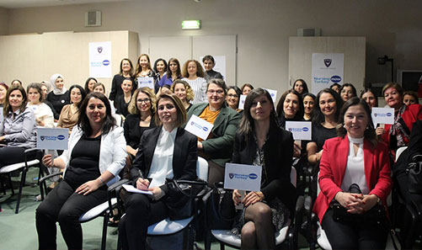

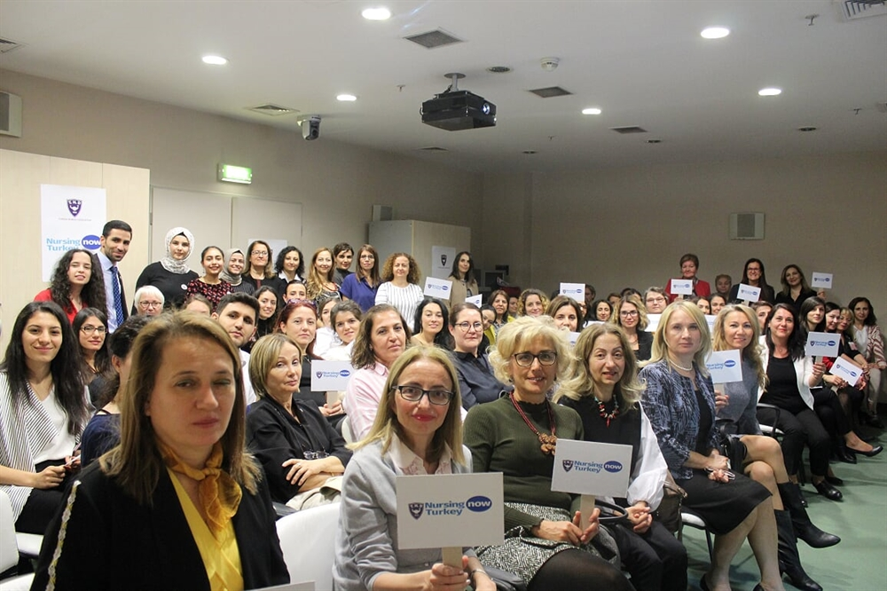

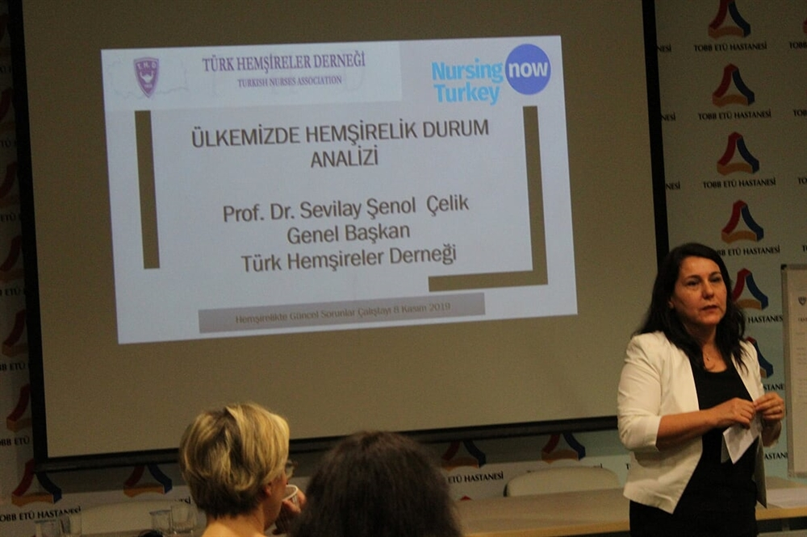

TURKISH NURSES ASSOCIATION STUDENTS COMMITTEE’S “1ST SYMPOSIUM ON NURSING STUDENTS”
As part of the Nursing Now campaign, the TNA Students Committee organized its First Symposium on Nursing Students on 23 November 2019 in Ankara. The symposium was hosted by a public university. Eight hundred nursing students from nursing faculties/departments of private and public universities from all around Turkey participated in the Symposium. The Symposium included a presentation on “Activities of the TNA, importance of occupational organization, and issues and questions on nursing education”, and also addressed the theme “What is a Special Branch Nurse and a Specialist Nurse?”. Within the scope of this theme, three special branch nursing associations made presentations about their activities. Participants identified the issues surrounding the symposium topics and discussed possible solutions.

